THE RELATIVE ABUNDANCE AND DISTRIBUTION OF BROOK TROUT SALVELINUS FONTINALIS AND TROUT INDICATOR SPECIES IN PANTHER CREEK, SCHOHARIE COUNTY, NEW YORK
SPRING 2004

Casey Michasiow
Ryan Santo
Rachel Vickers
Fisheries & Aquaculture
State University of New York at Cobleskill

Abstract

An electrofishing survey was conducted on Panther Creek in the spring of 2004 to assess the state of the brook trout (Salvelinus fontinalis) population following the termination of stocking thirty years ago. Fifteen sites were sampled on the creek and its’ tributaries. Brook trout were found at seven of the fifteen sites. The average length of brook trout was 133mm; the size distribution was from 85-245mm. There was only one site below West Fulton where brook trout were captured, indicating that the primary site of natural reproduction is upstream of the town of West Fulton.

Introduction

One of New York’s most popular sport fish is the brook trout, Salvelinus fontinalis. Due to progressive habitat loss and increased fishing pressure (over 1,550,000 anglers in New York State alone) trout management and stocking efforts are required for many smaller watersheds (Department of the Interior 2001).

Panther Creek is an example of past management and stocking efforts. It was stocked with trout fingerlings by the NYSDEC from 1925 through 1933. Follow-up surveys conducted by the New York State Department of Environmental Conservation (NYSDEC) in 1959, 1962, and 1971 indicated that trout populations were able to maintain themselves through natural reproduction, following stocking.

The goal of this survey was to determine the current state of the fish fauna of Panther Creek, with particular emphasis on the current state of the trout population. In order to meet this goal, this study greatly expanded the scope of previous NYSDEC surveys from a few sample sites to 15 sample sites. It is therefore the most comprehensive scientific survey ever conducted on Panther Creek and is the first fisheries survey of the Panther Creek watershed in the last 33 years.

Materials and Methods

Panther Creek originates in the Township of Summit, Schoharie County, New York (74 30’ 00”) and flows southwest into the Schoharie Creek at Breakabeen (see Map a-c). It is a high gradient, second order stream with much woody debris. The stream is well shaded by thick riparian vegetation and steep valley walls. Bouck Falls forms an impassible, 70-foot, fish barrier, which separates the upper reaches of Panther Creek from the fish fauna of Schoharie Creek.

Fifteen sites on Panther creek and its’ tributaries were sampled during April 2004. A Smith-Root backpack shocker set at ½ amps, for 500 seconds was used to sample each site. Two scappers followed the backpack operator. Both pools and riffles were sampled in order to cover a variety of habitats. Captured fish were identified, counted, measured and returned to their place of capture. Total length was taken on all trout captured.

Results

Brook trout were found at nearly every site sampled above the Town of West Fulton, but only site-7 below West Fulton contained brook trout. Tributary 1N had the greatest density (38%) and size (245mm) of brook trout.

A total of 29 brook trout were captured ranging in size of 85-245mm. The average brook trout length was 133mm (Figure 1). The range in size of trout captured indicates natural production and at least three year classes. However, only 10 % of the trout population was larger than 200mm, a size that would be attractive to anglers.

Typically coldwater streams in New York State contain trout, sculpins (Cottus sp.) and blacknose dace (Rhinichthys atratulus). While blacknose dace were present in the upper portions of Panther Creek, no sculpins were captured (Table 1) throughout the study. In fact, the upper portion of Panther Creek only contained brook trout, blacknose dace and creek chub.

Panther Creek’s fish fauna below Bouck Falls, was much more diverse, containing blacknose dace, longnose dace (Rhinichthys cataraca), common shiner (Notropis cornutus), white sucker (Catastomus commersoni), creek chub (Semotilius atromaculatus), and fall fish (Semotilus carporalis) (site-9, Table 1).
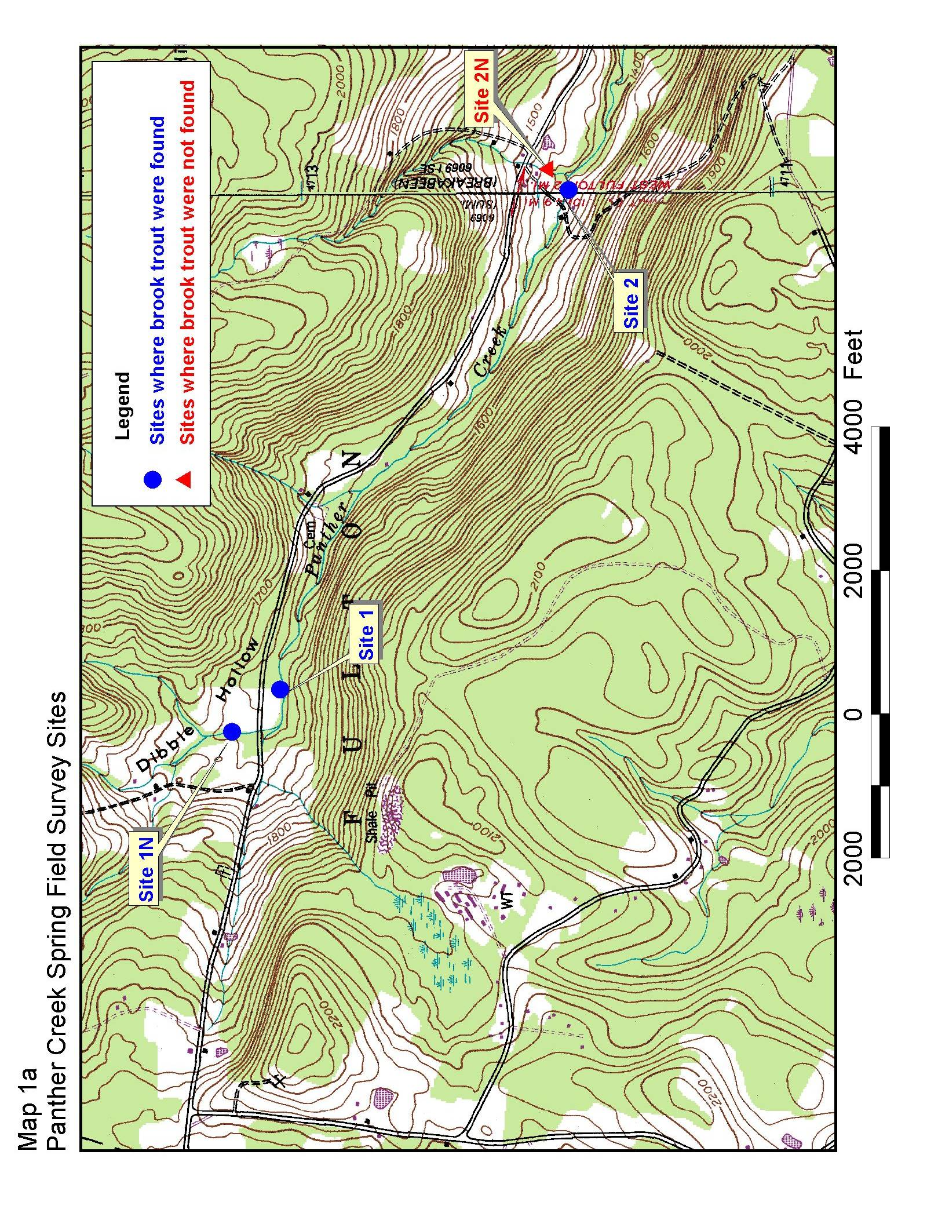
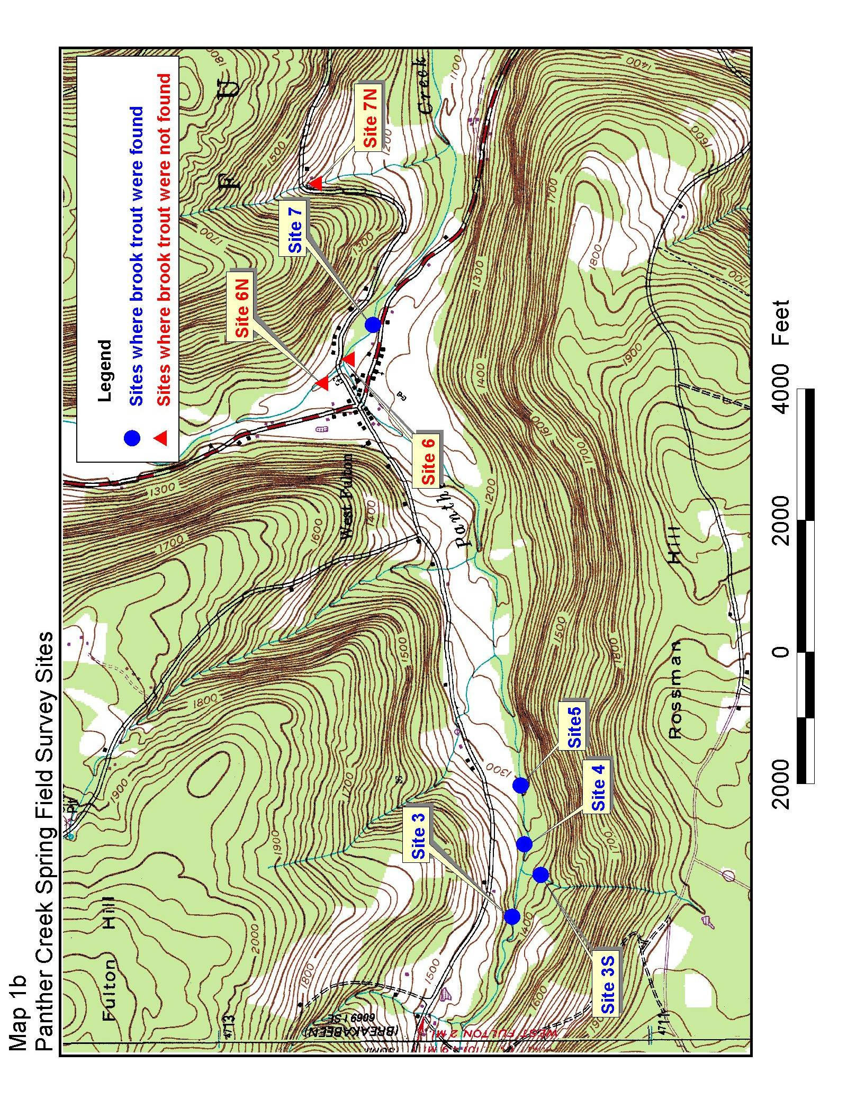
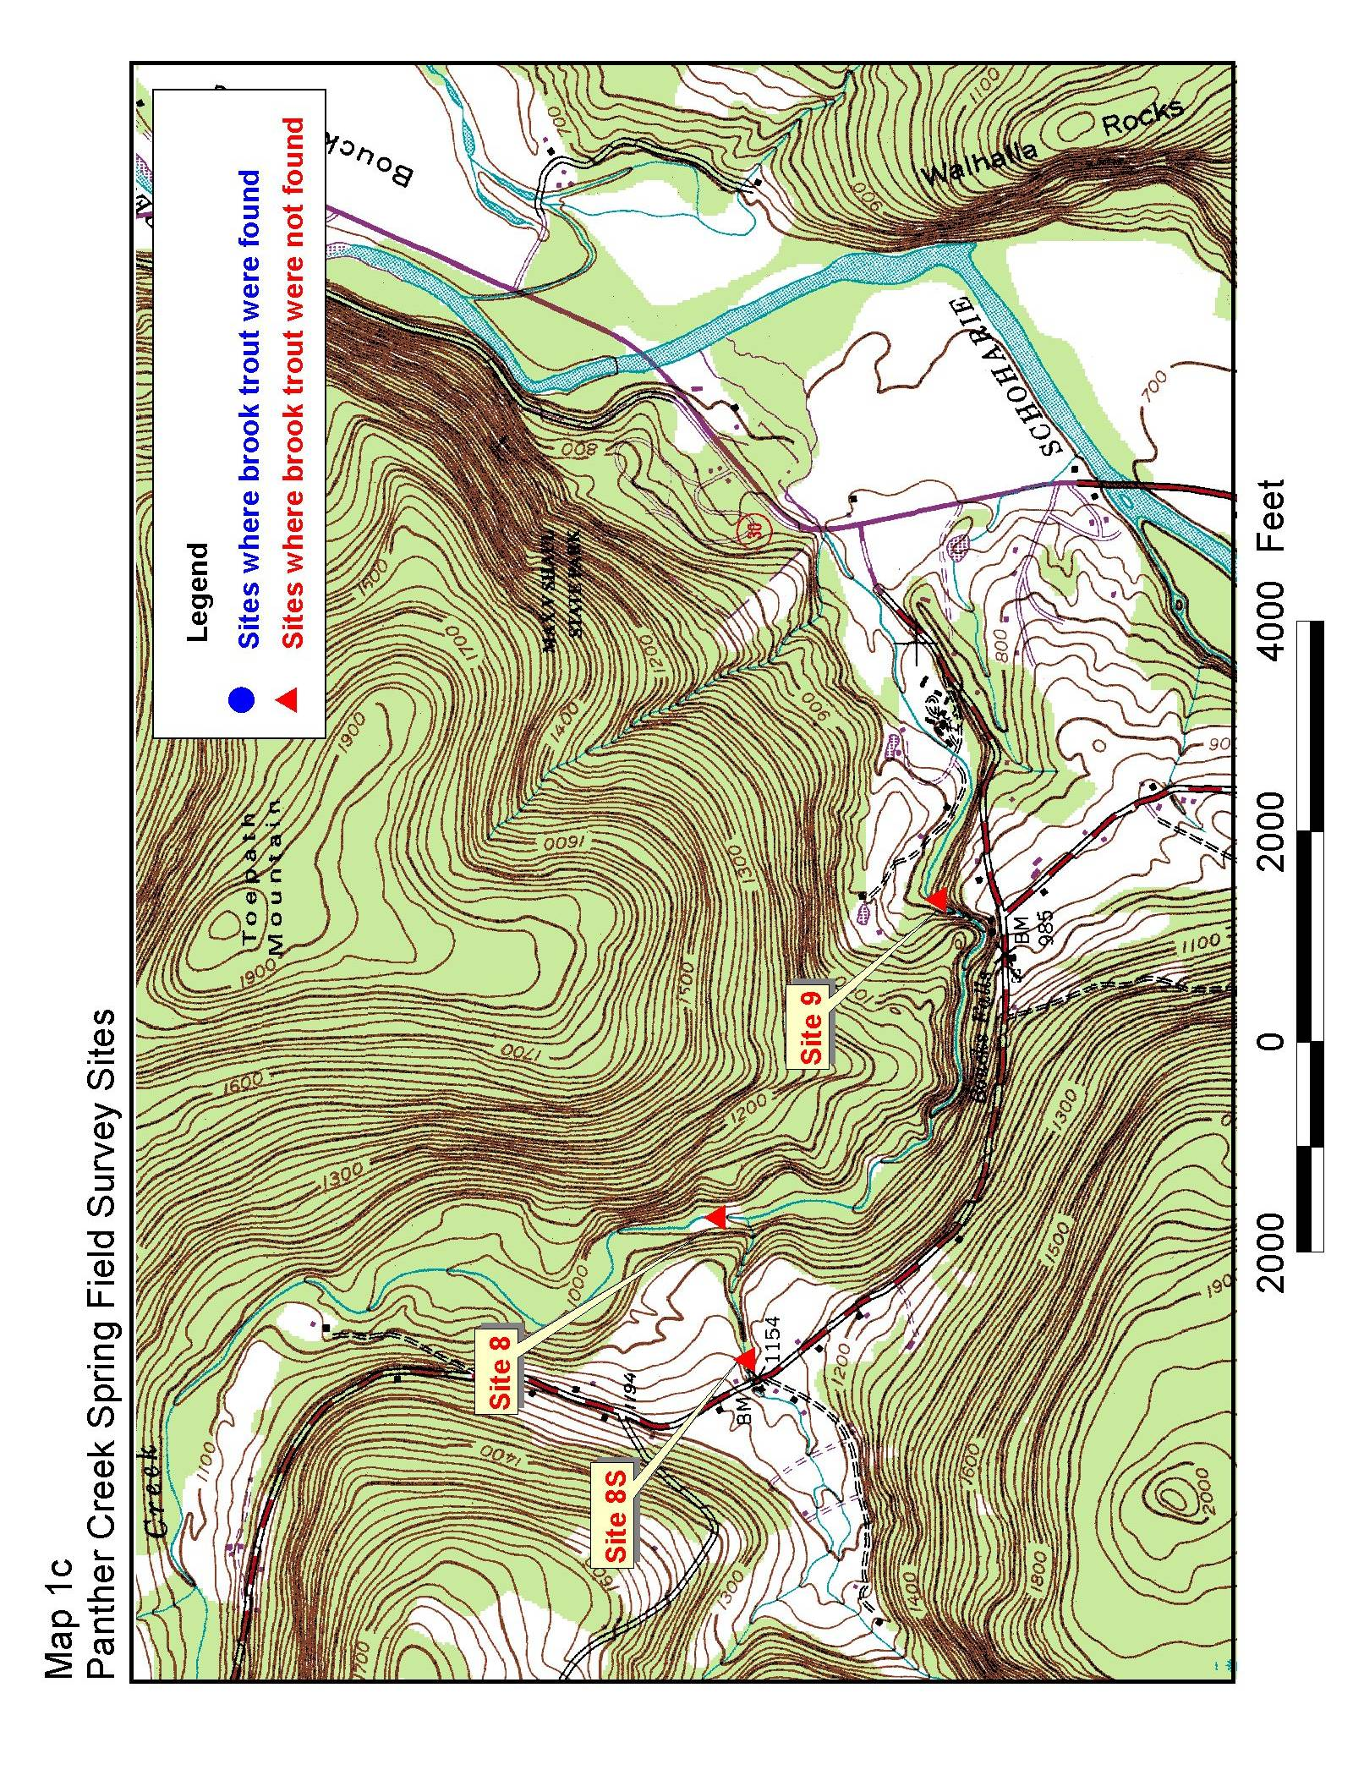
Table 1. The number and species of fish captured at each site.
Main stem | Brook Trout | Blacknose Dace | Longnose Dace | Creek Chub | White Sucker | Common Shinner | Fall Fish
1 | 2 | 20 |  | 1
2 | 2 | 2 |  | 1
3 | 5 | 5
4 | 3
5 | 2
6 |  | 14 |  | 8
7 |  | 1 |  | 14
8 |  |  | 8
9 |  |  | 10 |  | 5 | 31 | 1
Tributaries
1N | 11 | 4
2N |  |  |  | 1
3S | 4
6N |  | 17 |  | 3
7N
8S |  | 3

Figure 1.

Discussion

This study indicates that Panther Creek supports a self-sustaining brook trout population above the town of West Fulton thirty years after the stream was last stocked with trout. NYSDEC (data presented in Appendix A) found 144 brook trout at 8 sites, considerably more than the 29 brook trout captured at 15 sites in this survey. The lengths from the NYSDEC were similar to the data presented here with 99% of brook trout ranging from 50mm to 203mm.

Brook trout are expected to reach sexual maturity at a small size in small, low order streams and usually never reach a large size (Kendall 1914). Fecundity increases with size, for example a small brook trout of 144mm will produce 100 eggs and a 240mm fish will produce around 400 eggs (Vladykov 1956). Eighty-six percent of brook trout captured were in the 100-255mm range, which is the expected size of reproductively active brook trout in Panther Creek.

The results of this study were similar to the NYS Museum survey and NYSDEC (data presented in Appendix A). Both surveying groups did not find brook trout below Bouck Falls. A richer fish fauna was present below the falls. In fact, the NYS Museum survey found more than double the species (13) below the falls, than did this survey. This difference is probably due to the differences in the sampling dates of the two surveys. The NYS Museum survey was conducted in the summer when more species would be expected to have migrated into the lower reaches of Panther Creek.

All surveys showed that the fish fauna above Bouck falls was limited to a few species. Sculpins, a trout indicator species was not found in Panther creek in this survey or previous surveys. Blacknose dace and creek chubs, species often found in trout streams, were present in the upper reaches of Panther Creek.

This study sampled more sites than any previous studies. However, the high spring water levels made Panther Creek difficult to survey. Another comprehensive survey of Panther Creek should be conducted in the summer or early fall when water levels are lower and fish are more concentrated in pools.

Acknowledgements

This study was conducted under the supervision of Dr. John Foster. Trout Unlimited provided generous funding for the project. The Schoharie County Conservation Association provided a scholarship to each student who undertook the study. The State University of New York (SUNY) at Cobleskill provided equipment and training for all crews. The SUNY Cobleskill Fisheries Management class assisted with sampling. NYSDEC and NYS Museum provided data from their previous surveys.

References

Kendall, W.C. 1914. The fishes of New England. The Salmon Family. Part I. The trout or chars. Mem. Boston Soc. Nat. Hist. 8: 1-103
Vladykov, V.D. 1956. Fecundity of wild speckled trout (Salvelinus fontinalis) in Quebec lakes. J. Fish. Res. Board Can. 13: 799-841.

U.S. Department of Interior, Fish and Wildlife Service and U.S. Department of Commerce, U.S. Census Bureau. 2001. National Survey of Fishing, Hunting, and Wildlife-Associated Recreation.

Unpublished Material

NYSDEC 1971. Stream Survey Panther Creek.

NYSDEC 1962. Stream Survey Panther Creek.

NYSDEC 1959. Stream Survey Panther Creek.

NYSDEC 1935. Stream Survey Panther Creek.

NYS Museum 1983. Stream Survey Panther Creek.

NYS Museum 1996. Stream Survey Panther Creek.

Appendix A

NYS Museum fisheries surveys for Panther Creek.
Site located downstream of NYS Route 30.
July 7, 1983 | Number Captured
Blacknose Dace | 43
Cutlips Minnow | 2
Common Shiner | 1
Fantail Darter | 14
Greenside Darter | 1
Longnose Dace | 16
Creek Chub | 3
White Sucker | 1
September 4, 1996
Brown Bullhead | 1
White Sucker | 9
Cutlips Minnow | 3
Stone Roller | 6
Fantail Darter | 5
Creek Chub | 3
Fall Fish | 16
Common Shiner | 8
Spotfin Shiner | 3
Smallmouth Bass | 10
Longnose Dace | 29
Blacknose Dace | 5
Bluntnose Minnow | 2

New York State Department of Environmental Conservation
Previous stocking data for Panther Creek, Schoharie County, New York

 | 1925 | 1926 | 1927 | 1928 | 1929 | 1930 | 1931 | 1932 | 1933
Brook Trout | 0 | 1500 | 750 | 5600 | 3600 | 3550 | 1400 | 2825 | 1200
Brown Trout | 2300 | 2000 | 0 | 4500 | 1225 | 5000 | 2400 | 1500 | 2800
Rainbow Trout | 1800 | 1000 | 1000 | 2000 | 1225 | 625 | 1350 | 1000 | 1890

New York State Department of Environmental Conservation
Fish Survey Panther Creek, Schoharie County, New York

Date: 7/27/59
Location: just above T-7
Length of Shocker Section (feet): 250

Name of species | Number | Description
Salvelinus fontinalis | 33 | 4-8”
Rhinichthys atratulus | N/A | present
Semotilus atromaculatus | N/A | present

New York State Department of Environmental Conservation
Fish Survey Panther Creek, Schoharie County, New York

Date: 7/17/62
Location: at T-7
Length of Shocker Section (feet): 300

Name of species | Number | Description
Salvelinus fontinalis | 2 | 4-6”
Rhinichthys atratulus | 150 | 2-3”
Semotilus atromaculatus | 50 | 2-3”
Semotilus atromaculatus | 5 | 4-6”

New York State Department of Environmental Conservation
Fish Survey Panther Creek, Schoharie County, New York

Date: 7/17/62
Location: at T-5
Length of Shocker Section (feet): 300

Name of species | Number | Description
Salvelinus fontinalis | 8 | 2-3”
Salvelinus fontinalis | 25 | 3-4’
Salvelinus fontinalis | 25 | 4-6”
Salvelinus fontinalis | 9 | 6-8”
Rhinichthys atromaculatus | 200 | 2-3”
Semotilus atromaculatus | 50 | 2-3”

New York State Department of Environmental Conservation
Fish Survey Panther Creek, Schoharie County, New York

Date: 7/17/62
Location: 2.0 miles below T-7
Length of Shocker Section (feet): 300

Name of species | Number | Description
Salvelinus fontinalis | 7 | 2-3”
Salvelinus fontinalis | 10 | 4-6”
Salvelinus fontinalis | 6 | 6-8”
Rhinichthys atratulus | 300 | 2-3”
Semotilus atromaculatus | 50 | 2-3”
Semotilus atromaculatus | 10 | 4-6”

New York State Department of Environmental Conservation
Fish Survey Panther Creek, Schoharie County, New York

Date: 8/13/71
Location: 0.2 miles above T-4
Length of Shocker Section (feet): 300

Name of species | Abundance | Number | Description
Salvelinus fontinalis | A | 33 | 2.1-3.3”
Salvelinus fontinalis |  | 1 | 10.3
Rhinichthys atratulus | C
Semotilus atromaculatus | R

New York State Department of Environmental Conservation
Fish Survey Panther Creek, Schoharie County, New York

Date: 8/13/71
Location: 0.4 miles below T-3
Length of Shocker Section (feet): 300

Name of species | Abundance | Number | Description
Salvelinus fontinalis | R | 1 | 2.4
Semotilus atromaculatus | A
Rhinichthys atratulus | A
Notropis cornutus | C

New York State Department of Environmental Conservation
Fish Survey Panther Creek, Schoharie County, New York

Date: 8/13/71
Location: 1.0 mile below T-2
Length of Shocker Section (feet): 300

Name of species | Abundance | Number | Description
Salvelinus fontinalis | R | 1 | 2.3”
Rhinichthys atratulus | A
Semotilus atromaculatus | C
Semotilus corporalis | C
Rhinichthys cataractae | R
Notropis cornutus | R

New York State Department of Environmental Conservation
Fish Survey Panther Creek, Schoharie County, New York

Date: 8/13/71
Location: 1.0 mile above mouth
Length of Shocker Section (feet): 300

Name of species | Abundance | Number | Description
Salvelinus fontinalis | R | 6 | 2.0-2.5”
Micropterus dolomieui | R | 5 | 2.0-2.5”
Hypentelium nigricans | C
Semotilus corporalis | A
Catostomus commersoni | C
Etheostoma blennioides | R
Etheostoma nigrum | C
Semotilus atromaculatus | C

