Minutes from Schoharie County Conservation Association
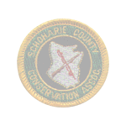
Meeting held at Curtis Mott building on the Cobleskill College campus, sponsored by the Fisheries and Wildlife Classes on March 22nd at 7:00 PM
Fellow Sportsmen & Sportswomen

*Attendance is needed from each club
for their input on club activities*

The meeting was called to order at 7:10. There were 29 in attendance. Walt Zeh made a motion and second by Doug Handy to pay the bills. Willy Karlu made a motion and second by Duke Mann to accept the minutes. Doug Handy made a motion and second by Bob Britton to approve the Treasurer’s report. We still have the SCCA hatpin available. To get a pin you must attend a SCCA meeting and be an associate SCCA member or a member of a dues paying club.
Ray Zeh made a motion and second by Duke Mann to write a letter to Remington Arms for support for NYSCC for Grassroots News Letter.
County will again host canoe raffle for Cobleskill fair – Committee selected. We have been approached by the fair board to think about moving the SCCA fair display to a different area because of the new building being constructed in the parking lot behind the building we are currently in. We have two choices. We can move back into a tent or we can construct a new building 16’ x 24’ on skids which could be moved if needed. Dave Wood made a proposal to chair a committee to build this building; 14’ X 24’ at his home residence and then move to fair grounds. He stated he would have estimate for materials for next meeting.
Harold Palmer, President of the NYSCC was our Guest speaker. He discussed a legislative Bill # A3878 and #S5857 which is for allowing 14-16 year olds to hunt big game with a gun. He gave a report on the council’s finances. He stated that the council is doing ok but they have reduced their staff to one full time and one part time. He said Sportsmen & Sportswomen need to stick together on issues. This is why Remington Arms withdrew their support. He discussed the crossbow issue and they are looking at changing the guidelines to make it easier for handicapped hunters. At last month’s meeting a motion was made by Doug Handy to purchase a Lap top computer for the SCCA secretary. Second by Willy Karlu. A vote was taken and passed not to exceed $1000. (Still getting prices)
Members voted on paying for 4 youths to go to Camp Coby which passed, wrote out a check for $1000 to DEC Camps. Each camper will take pictures to make up display for Cobleskill Fair Display.
Gun Hunter Safety course: Will be given at the Middleburgh Rod & Gun Club – Registration Date 04/23/07 - 7PM to 9PM. Class dates are April 27th, 28th, 6 PM – 9:30 PM NO WALK INS!!!! Correction: Last month’s newsletter stated there was a new hunter’s safety requirement – all students must be trained with the use of live firing. This has not been approved yet. It is being considered and may happen in the near future.
Trapping Course: There were 41 new trappers certifications handed out at the trapping course held at the Middleburgh Rod & Gun Club.
SCCA Association Dues: $30 Dues for associations & $10 for individual memberships. Please send to SCCA, P.O. Box 325 Central Bridge, NY 12035.

Spring 2007 Trout Stocking Targets for Schoharie County
The following listing reflects the anticipated number of yearling and older trout to be stocked into listed waters during spring 2007. Actual numbers and stocking times may vary depending on fish availability and weather conditions. The fish are stocked with help from County Federated Sportsmen.
Schoharie County, DEC Region 4
Water | Town | Number | Date | Species | Size (inches)
Holding Pond | Cobleskill | 170 | April | Brown Trout | 8 - 9
Holding Pond | Cobleskill | 180 | April | Rainbow | 8 - 9
Holding Pond | Cobleskill | 120 | May | Brown Trout | 12 -15
Mallet Pond | Fulton | 190 | Spring | Brown Trout | 8 - 9
Mallet Pond | Fulton | 200 | Spring | Rainbow | 8 - 9
Schoharie Res | Schoharie | 1,750 | Spring | Brown Trout | 8 - 9
West Kill | Blenheim | 420 | April | Brown Trout | 8 - 9
**NOTE: Stocking of the New York City reservoirs is contingent on the reopening of the reservoirs to public access.

Research on the population status and foraging ecology of
Eastern Coyotes in New York State
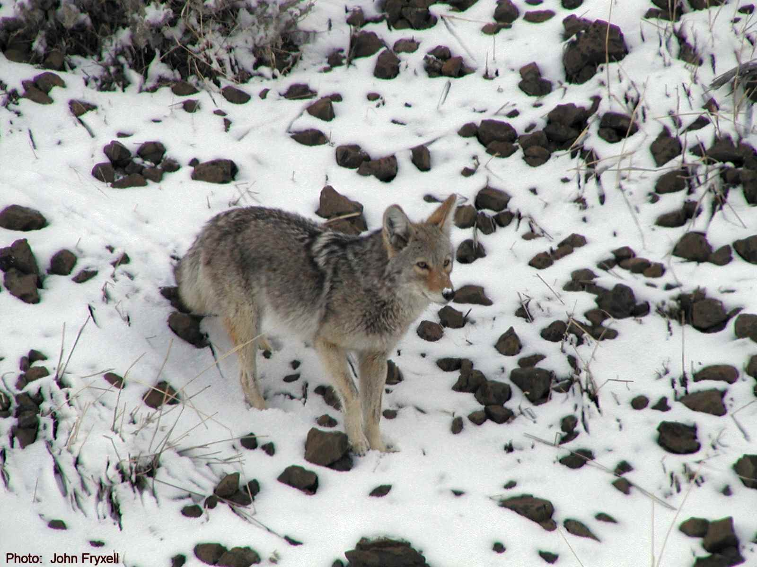
Photo: J. Frair
Dr. Jacqueline Frair and Dr. James Gibbs,
SUNY College of Environmental Science & Forestry
Gordon R. Batcheller and Paul Jensen,
NYS Department of Environmental Conservation

Coyotes expanded their range into the northeastern United States following the extinction of wolves and cougars around the turn of the 20th Century. Occurring in New York State only since the 1920s, coyotes today are the most widespread and abundant large predator throughout the state. Northeastern coyotes are larger than their western relatives, and share behavioral traits with eastern wolves (Canis lupus lycaon), such as preying on white-tailed deer. Coyotes play an essential role in the regulation of small mammal and mid-sized predator populations in certain areas, but it remains unknown whether they play a role in regulating populations of deer. Given their recent and rapid population expansion in the Northeast, land and wildlife managers are particularly interested in how much coyotes may affect deer populations and, by extension, the functioning of ecosystems.

Little is known about the status or food habits of coyote populations around New York State. Detailed study of coyote behavior and interactions with deer in the state has been undertaken in the Adirondack region only. This research will fill critical knowledge gaps using a combination of intensive studies of radio-collared coyotes in focal areas and broad-scale sampling of coyote abundance and diet throughout the state. The work is in its initial phases and will be completed by graduate students at SUNY-ESF under the direction of Drs. Jacqueline Frair and James Gibbs in cooperation with the NYS Department of Environmental Conservation.

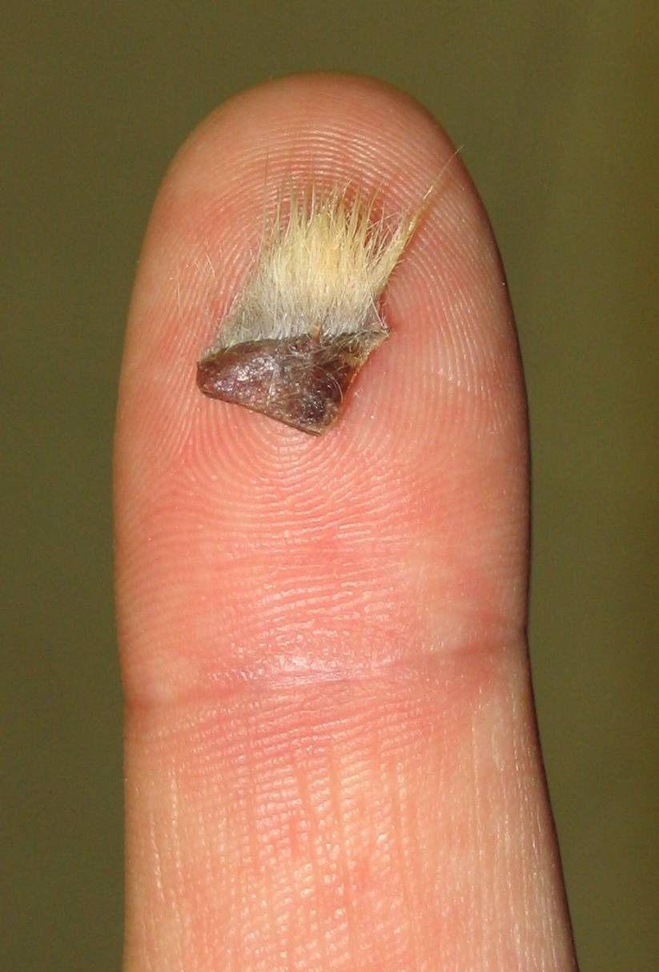
How you can help: Prior to defining study areas, we are investigating whether separate subpopulations of coyotes (genetically distinct groups) exist around the state. We are seeking samples of coyote DNA during winter 2006-07. DNA can be easily extracted from a small sliver of skin from untanned hides (see actual size of skin sample required in photo at left). This skin sample can be taken from around the feet or other unobtrusive areas. Alternatively, a larger piece of meat removed from the carcass provides a good sample as well. It is critical to record where the animal was collected so we can map the sample location to within approximately 10 miles. Our goal is to acquire 5-20 samples (individual animals) from each county around the state. If you have hides or carcasses that we might collect samples from, please contact Dr. Jacqueline Frair, jfrair@esf.edu, 315-470-4905.
Photo:
A. Newhouse

NYSDEC: SPRING TURKEY SEASON SET TO OPEN SOON

For Release: IMMEDIATE Contact: Lori O’Connell
Tuesday, April 17, 2007 (518) 402-8000
DEC Studies Suggest A Mixed Forecast For Spring 2007

New York State Department of Environmental Conservation (DEC) Commissioner Pete Grannis today announced the dates for New York's spring turkey hunting seasons, including this year’s annual Youth Turkey Hunting Weekend. The spring season for all hunters opens on May 1, 2007, and the special Youth Turkey Hunting Weekend was held on last weekend, April 21-22.

Wild Turkey Banding Study - In January 2006, DEC began a four-year wild turkey banding project designed to estimate harvest and survival rates of male wild turkeys (gobblers) in New York. This study is being done in cooperation with the Pennsylvania Game Commission, Ohio Department of Natural Resources, researchers from Pennsylvania State University, and the National Wild Turkey Federation. In winter 2006, DEC banded 296 gobblers and 81 (27%) were reported taken by hunters during the 2006 spring season. Several birds were taken more than 20 miles from their winter capture location.
In winter 2007, DEC staff and volunteers banded another 381 gobblers, far exceeding the annual statewide goal of 300 birds. Returns from the spring 2007 hunting season will be analyzed by researchers at Pennsylvania State University to further examine harvest rates, harvest reporting rates, and movements of birds across the state landscape. DEC thanks all of the volunteers and cooperating landowners for their invaluable assistance in the field. This project would not be possible without them.

Negative Issues in the News: First part of April - We have been informed that Albany Mayor Jerry Jennings plans to propose a gun control package to the Common Council that would include:
* Registering ALL firearms within the city
* Prohibiting private gun sales
* Registering all sales and requiring dealers to provide that
Information to the police
* Outlawing "high caliber" ammunition including 9mm and .357
* Mandatory storage
We have also been told that the Common Council will be voting on this
Tomorrow April 8th.

April 16th: The following bills are on the Senate Agenda:

Larkin S.233 -- Would extend deer seasons into January for all unfilled licenses, DMU permits, DMAP permits. This essentially takes deer management out of the hands of DEC and gives it to the Legislature and farming
interests. The only thing DEC could do is severely restrict the availability of the above licenses and permits. The Senate passed this bill last year. Larkin is a "Republican friend of the sportsmen," supported by
the NRA, from Orange and Ulster Counties. He is the Sponsor of a bill to create a deer task force (that does not include sportsmen) to increase doe permits when over browsing is present that has already passed the Senate (S.
538); and a bill to allow commercial hunting of deer on farmland (S.239). When these bills pass both houses Commissioner Grannis will be asked if DEC wants the bills vetoed.
Marcellino S.2759 -- This bill would insure that your license information is confidential and could not be sold or shared with other parties. The NYSCC (not the NRA) went to court to stop the attempt by the NYS Assembly and Senate to get this information, thanks to President Cushing.
Bill # S.233 & S.239 Are no good. If they pass it would take out the deer herd. If you think that the deer population is low now then think about if you shot all the deer on unfilled licenses to.
Bill # S.2759 (Support) The government does not need to know the information on our hunting license.
NEW NYS DEC COMMISSIONER VOTED IN:
One significant vote has been taken by the GOP-controlled state Senate so far today: The one confirming Alexander "Pete" Grannis as the state's DEC Commissioner. Grannis wore his flying duck tie for the occasion - the same tie he wore Tuesday when he got the nod from the Senate EnCon Committee, only to be
stalled in the Finance Committee due to budget wrangling. Eighteen senators - 17 Republicans and one Democrat - voted no today. They were: DeFrancisco, Farley, Griffo, Lanza, Leibell, Libous, Little, Maltese,
Maziarz, Nozzolio, Rath, Robach, Seward, Valesky, Volker, Winner, Wright, and Young.
When ever there is a political regime change there usually are several political positions that are affected. There are nine Regions within the New York State Division of Environmental Conservation with nine Regional Directors which are all political appointed positions. With a new Governor in place anything can happen.
NYSCC: REGION 4 Meeting: We had 10 guest speakers with only about 40 members in attendance!!!! I was a little embarrassed with the turnout. Highlights of different speakers:

Harold Palmer presented Dave Wood the Conservation Award and reviewed the March On Albany.

Assemblyman Bob Reilly - Talked about farmlands disappearing, no crops planted, the need to bush hog, need to increase support to agriculture through grant and subsiding.
Wally John - Manhattan (No junior licenses sold) All of NYC only 121 small game licenses sold. There is a 4 to 1 ratio between youth and average hunter. Need to promote the youth hunters. Need to support CFAB.
Dick Henry - Buck take trend about the same as 1970. DECALS changes 2007 tag colors gray, yellow, and green. Internet reporting with voice recognition software. CWD update, Reviewed pilot antler restriction program 3C, 3H, 3J, & 3K. Deer Watchers Program, Deer Density Estimation, Deer Reproduction Study, and Beer Hunting take Statewide.
Senator Seward – Hunters helping Upstate economy, Discussed DEC Commissioner Vote, Fish Hatchery Funding, Bill # S2639 The Right to Hunt, Fish & Trap in NYS Constitution, Bill # S2179 which provides Tax credit for land owners improving forest and habitat for wildlife, discuss VHS disease meeting with Pete Lopez to be held in Catskill.
Bud Woodfield (CFAB Rep) – Gave update on Conservation Fund Finances, down 13,400 license sales from last year ($300,000 plus). New Governor appointment for Region 4 CFAB is Alan Rosa. Chairmen of CFAB, Bob Monachio resigned. Discussed Summit Meetings (CANY, CFAB, NYSCC). Reviewed arbitration of pay for ENCON Officers and how it affected conservation fund, (French Benefit package needs to be funded by State General Tax Fund), and reviewed Habitat Stamp Program Funds. By law CFAB must report to DEC Commissioner.
Pete Innes (DEC Natural Resource Manager Region 4) Reviewed 5 applications for Habitat Funding Projects. Funding available is $100,000. Total amount applications statewide $350,000. Reviewed Open Space Program – acquired 12.5 million square yards or 2500 acres during the last year, which is open for hunting fishing & trapping. Also reviewed NYS DEC Internet Website for on-line mapping.
Kevin Berner – Gave a powerpoint presentation on the Alaska trip where students participated in a National Quiz Bowl along with pictures of landscape and various animals. Next trip will be to Tuson, Arizona on September 20 – 26. Will host Wildlife Festival on April 28th from 10AM to 4PM.
Steve Lawrence, DEC Fish Manager from Stamford – Discuss the VHS Disease (Viral Hemorrhagic Septicemia). This disease can kill a significant number of fish species, affecting a large number of species, Cold water disease, transmissible to fish of all ages and poses no risk to human health. He also reviewed new regulations, which restrict the movement of baitfish from different water bodies. Concern about spread between hatcheries.
Lt. Larry DiDonato, Supervising ENCON Officer – Reviewed illegal hunting which affects all sportsmen. Reported on several cases where poaching deer was involved. Biggest violation to date is fishing with no license. Last line of defense is the Green Line - 230 Uniform ECON officers covering 62 counties. There were 12 arrests for jacking deer in Region 4 during the 2006 season. June 23 & 24 Free Fishing Days.
Fish & Wildlife Management Board: Of the following five projects, the 2000 foot restoration on Ten Mile Creek was approved by DEC as of this date. Region 4 received five applications for grants from Habitat/Access program within Region 4. The first application was submitted by The Catskill Watershed Corp., a project that will provide up to three car public parking areas at five properties now owned by New York City Department of Environmental Protection. The second application submitted by the Green County Soil & Water Conservation District, a project which would include restoration of 2000 feet of stream on the 10 Mile Creek, Town of Durham. The third application was submitted by the Village of Athens, a project that includes a dock and car top boat launch for Kayaks & Canoes located on 4th street in the village of Athens. The forth application submitted by the Town of Glen, a project to create a public access location along the Mohawk River to provide boaters & anglers the opportunity to utilize the resources of both river and surrounding lands. The last application was submitted by The Nature Conservancy (The Albany Pine Bush), a project to increase wildlife habitat by removing 1.5 acres of invasive Black Locus and replant high quality pitch pine scrub oak.
The total amount of Habitat/Access Stamp sales for the past two years is close to $100,000. Of the nine Regions in New York State there are three which did not get selected to receive a Habitat/Access award. Region 1, 7 and 9 did submit projects but were not selected as of this date. Final awards have not been advertised and everything is subject to change.
Mike Zeh attended the FWMB Spring meeting March 29th, 30th, and 31st which was held in Schenectady. This is a statewide meeting with all nine regions represented by a Sportsmen Rep, a landowner rep. and a legislative representative. A full report will be submitted next month.

NWTF – A good turn out at the Banquet this past weekend with 85 in attendance. A total of $13,000 in proceeds was raised to help continue the on going project of clear cutting certain sections of New York State land located near Eminence. Karl Parker, a local NYS DEC representative is over seeing the project. There will be a booth at the Wildlife Exhibit on April 28th. For more information please contact Liz Reinhart 518-673-3965 or call the NWTF, @1-800-THE-NWTF. Meetings are now held on the 3rd Wednesday of the month at Liz Reinhart home residence - 256 Melick Rd. Canajoharie, NY 13317
SUNY Cobleskill College: Had two presentations. Isaac Golding & Ericka Reinicke gave us an update on the walleye-stocking program in Otsego Lake and where it’s going. They show the tracking of five walleye tagged with sonotronic acoustical tags over an eight month period. Currently walleye are under-utilized as a fishery in Otsego Lake. This study will give anglers a better target area for their fishing efforts.
The second presentation was given by Josh Meacham & Erin Swartwood. Their report was on working with DEC employees on the CWD Review by taking brain stem, tonsils, and lymph nodes samples from deer, ID with bar codes and sending to Cornell for test. Within Region 4G & 4H close to 500 samples were taken. Game Diner was held on March 31 @ 6:00PM Venison & Goose – $7 tickets. Will host the Wildlife Festival on April 28th from 10AM to 4PM which is free to the public.
Central Bridge Fish & Game Club– Skeet shooting is open to the public on Sunday at 9:00 a.m. sharp on mornings all year weather permitting. Contact Jim Mansheffer at (518) 868-2576. The club also sponsors the Schoharie Pistol Team that uses the range at the clubhouse. The team is looking for shooters. For info http://www.schoharie-conservation.org/memberclubs/cbfgc.html
Middleburgh Rod & Gun Club: 44 in attendance at March meeting. Guns vs. Cash – Guns won 46 to 9. So it’s Guns again this year. The Guns have all been purchased and are locked up at the Schoharie County Jail until December. Trap shoots will start again April 27th. Will be sending two youths to Camp Coby, $250 each (DEC Environmental Camp). Fish Derby will take place on June 9th. Voted 4 new members in and read 7 applications for next month’s voting. NYS Wide Muzzleloader Event July 27, 28, 29 at the club. For more information check out the club’s website address. www.middleburghrg.com.
Whitetails Unlimited Meeting was held March 5th. Same officers voted in. John Bloomer – Pres., Ernie Ostrander – V. Pres., Mike Zeh – Treas., Bill Nelson –Sec. The next meeting will be held in June at the Middleburgh Rod & Gun Club. Motions were made to pay the fee charged for a youth to attend Camp Colby and also $250 for the college student lunches on March 24th. Our website address is: www.schoharie-conservation.org/memberclubs/scwu.html.
West Fulton Rod & Gun Club: Clayon Adams won the drawing on the canoe raffle. Still need workers for the pavilion behind the firehouse. The club is planning a 5K run third Saturday in June (Partridge Nest 5K Run). The club is sponsoring this event on behalf of the Town of Fulton Historical Society to raise funds for the moving/setup of the school house which was original in Vininton located on road between West Futon and Warnerville.
The SCCA meeting was adjourned at 9:40 PM.
SCCA website address is http://www.schoharie-conservation.org/ My e-mail address is mzeh4@nycap.rr.com Please update your address book/list. Please send any information, which I will try to include in future SCCA newsletters. I appreciate all the help I can get. Mike
The April meeting of the SCCA will be Thursday April 26th, 7:00 PM, at the Middleburg Rod & Gun Club.
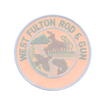

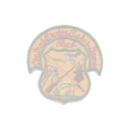
This month's speakers will be Assemblyman Peter Lopez. He will present an update on the progress of the TEA 21 project. This is the proposed walkway on the Schoharie Creek from Route 7, Central Bridge to the Schoharie Annex. Howard Bartholomew from Trout Unlimited will be updating us on the trout populations in the Schoharie Creek and Kevin Berner will have SUNY Cobleskill student presentation.


